During the deployment of Azure Logic Apps in the UAT and Production environments, an issue was identified related to the Service Principal 'cn02u-aslaintbkgpdt-slaswgcor.' This Service Principal is a member of the Active Directory (AD) group 'UAT DB-UAT-sunwingprod-RWX.' Users reported access issues, prompting an investigation into the cause.
Upon scrutiny, it was observed that the Service Principal was not functioning as expected when utilizing the permissions granted through the 'UAT DB-UAT-sunwingprod-RWX' AD group. In contrast, the permissions assigned via the 'DEV DB-DEV-sunwingprod-RWX' AD group, which was operational in the UAT environment, were examined for comparison.
A thorough analysis revealed that all permissions for both AD groups were configured correctly and matched accordingly. Despite this, the Service Principal 'cn02u-aslaintbkgpdt-slaswgcor' was not functioning as intended when utilizing the permissions granted through the 'UAT DB-UAT-sunwingprod-RWX' group.
To study this behavior, we have analyzed how the service principals have been set up and to our surprise everything was symmetrical across the AD groups (the UAT Service Principal and DEV Service Principal).
We opened a case with Microsoft (TrackingID#2312010040010416).
We worked with Microsoft and provided them with all the details pertaining to this issue.
Below is the step-by-step troubleshooting process that we have followed:
- Set up a call with the Dev, DevOps, and Database Team members to capture the error message when we attempt on removing the service principal which was added explicitly as a work-around to resolve the access issues.
- We removed the login ‘cn02u-aslaintbkgpdt-slaswgcor’ and we observed below error messages in the SQL error logs and in the logic app side.
SQL Server Error Message”
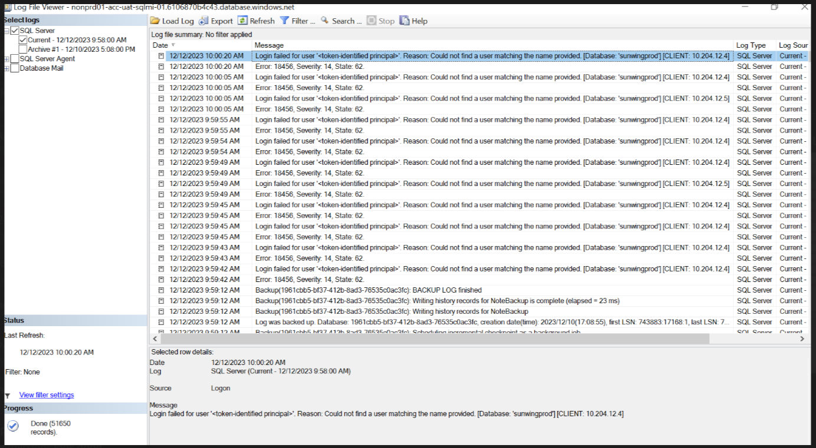
Logic App Error Message:
Failed to start SQL trigger listener for table: 'dbo.DBOOKING', function ID: 'e9e15a092e56beba'.
Exception: Microsoft.Data.SqlClient.SqlException (0x80131904): Login failed for user '<token-identified principal>'.
at Microsoft.Data.ProviderBase.DbConnectionPool.CheckPoolBlockingPeriod(Exception e)

- Upon bringing the error messages to Microsoft, we first checked if the service principal is user managed identity or a system managed identity. Opened the Azure Portal and checked the UAT Service Principal (Logic App) and figured out that it is a System Managed Identity
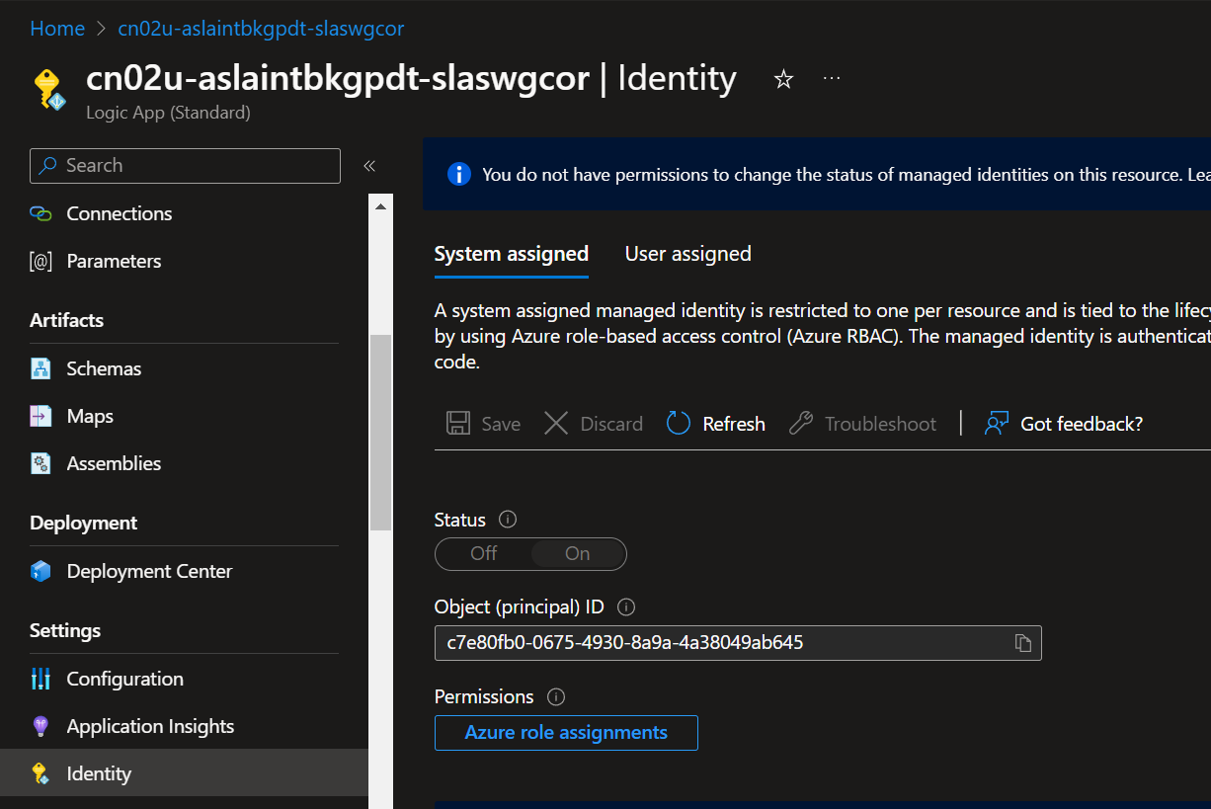
- Next goal was to check why token was not able to be identified and this check can’t be done from SSMS since we can only check the authentication of a user managed identity and not for a system managed identity.
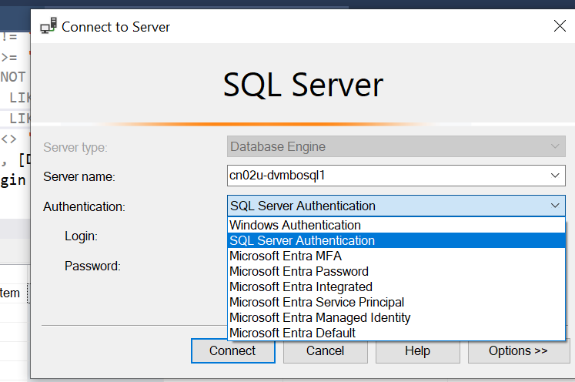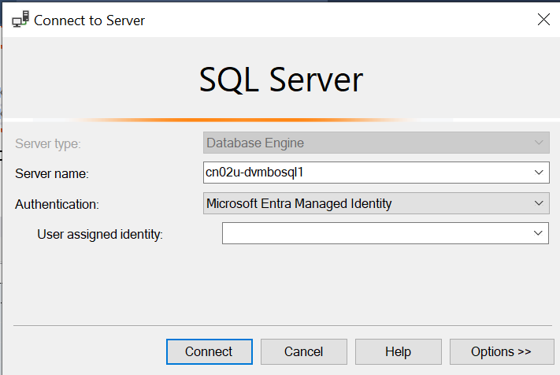
- To check the authentication of token, we need to decode token. Please follow the below steps for decoding the token:
  - Navigate to the respective service principal and go to Advanced Tools (Kudu) and launch the terminal. Click on Debug console and choose PowerShell
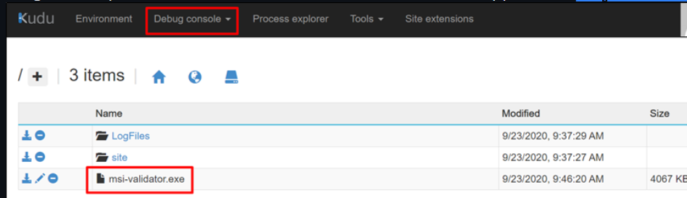
  - Use the below link to download the MSI validator.exe
https://techcommunity.microsoft.com/gxcuf89792/attachments/gxcuf89792/AppsonAzureBlog/160/1/msi-validator%20v1.0.0.0.zip
  - Upload the msi-validator.exe to upload it to the terminal.

  - Execute below command to get the token
msi-validator get-token -r sql (Access token should be returned otherwise it indicates that MSI service has issues reaching out to AAD to fetch token)
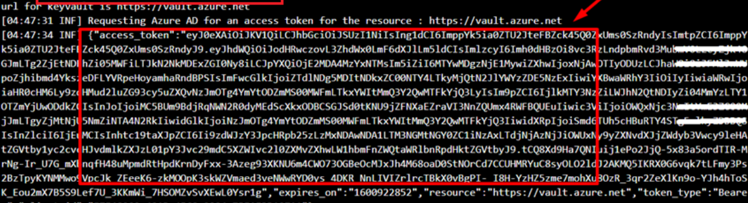
  - Copy the token returned and delete the last line of the token having the double quotes.
  - Past the token in the https://jwt.ms/ and click on Claims.
  - In the Claim type, we found the presence of AD group
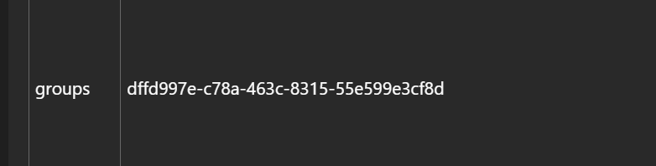
At this point, it was confirmed that token is being rightly generated. However, there is a disconnect between AD group in the Entra portal and the one which was being setup in the SQL Server.
- We executed the below queries to find if there is any disconnect between the two (AD group in the Azure Entra Portal and the AD group being setup as login in the SQL Server)
go
select @@servername, name, SID, cast(sid as uniqueidentifier) AppID, [type], type_desc
from sys.database_principals
where type in ('E','X’) AND name='DB-UAT-sunwingprod-RWX'
- We found out that Object Ids do not match the AD group DB-UAT-Sunwingprod-RWX.
SQL Server --6658CD2A-384B-4898-8882-783ACE156F16
Azure Entra Portal --dffd997e-c78a-463c-8315-55e599e3cf8d
Does Not Match the Object ID for UAT
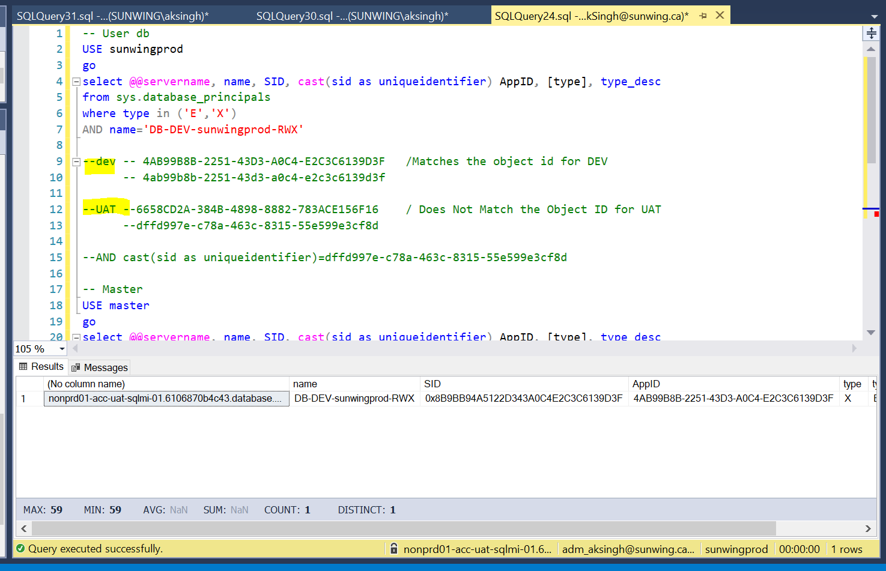
- To implement the fix, we must sync the object Id/App Id of the AD group in the Entra with that of SQL Server.
- We have set up the meeting again with DEV, DevOps and Database Team members removed the individual login and removed the DB-UAT-Sunwingprod-RWX AD group login from SQL Server.
USE [master]
GO

/****** Object: Login [DB-UAT-sunwingprod-RWX] ******/
DROP LOGIN [DB-UAT-sunwingprod-RWX]
GO

/****** Object: Login [DB-UAT-sunwingprod-RWX] ******/
CREATE LOGIN [DB-UAT-sunwingprod-RWX] FROM EXTERNAL PROVIDER WITH DEFAULT_DATABASE=[sunwingprod], DEFAULT_LANGUAGE=[us_english]
GO

- The Dev Team has confirmed that issue has been resolved and we have closed the case.

https://sunwing.freshservice.com/a/tickets/137226?current_tab=details SR having Fix Details
Attached is the email trail for reference that went with Microsoft.

